**Yahoo Weather Application**

I have used Yahoo weather API to develop the android application

This app consists of login page and after every successful login it redirects to Yahoo weather reporting web service.

Below are the brief explanation of steps taken to develop this application

First, in activity_login.xml created a login view like below and In activity_weather.xml the webpage for weather reporting is designed.

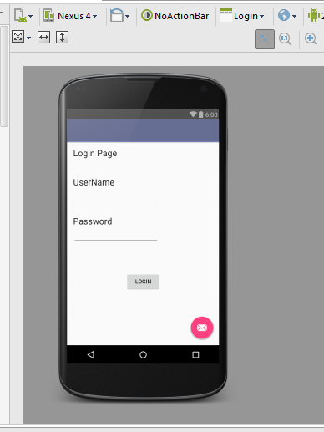

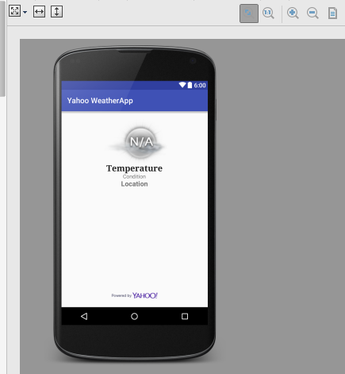

In Login.java the code for login, intent declaration, redirecting the successful login to yahoo web page are written and WeatherActivity is main class for Yahoo weather reporting service.

In Login.java file LoginButton() method takes username ,password And the redirection to web service is done through intent in this method. For every successful login, WeatherActivity class is called, it is the main activity for webservice.

After entering the credentials in the below login page and clicking the Login button, it displays “username and password correct” message if the credentials are correct. And redirects to weather service.

Below screen shots shows how login page occurs and Weather page occurs.

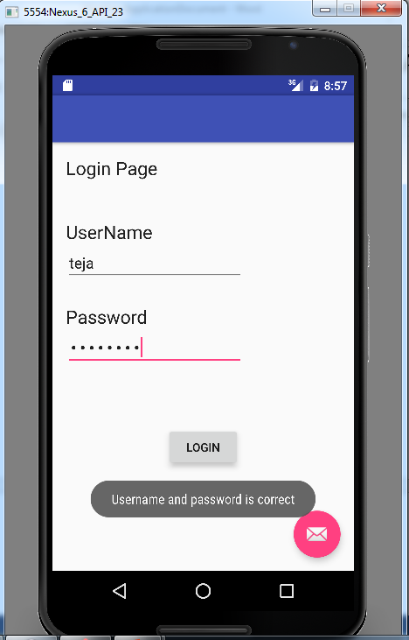

Below is the screenshot for Yahoo weather reporting web service.

